Thruxton Parish Housing Needs Survey
2024
YOUR opinion counts!

Please complete this
Thruxton Parish Housing Needs Survey,
undertaken on behalf of Thruxton Parish Council.

This is a way to help Thruxton Parish Council understand the current Parish housing need and ensure future development in your Parish is shaped accordingly.

Please return by 23 June 2024 to:
- The Post Box on the Village Hall railings or
- Await collection from your doorstep
on 22/23 June 2024

If you need help to fill in this survey, we can assist you. Please contact Bill Brewer on 01264 772909 for further help and information.
This is a Housing Needs survey for the whole Parish, not just Thruxton Village. The Parish Council needs to hear from Parishioners in Thruxton Down, Dauntsey Lane (including Amesbury Road) and Parkhouse Roundabout too please.

Dear Thruxton Parish Resident,
Your Parish Council is looking to review the Neighbourhood Development Plan (NDP) for Thruxton Parish. To inform this review, the initial stage is to investigate Parishioner’s current opinions on housing needs. This survey sets out to do this and its results will help determine the housing need for the Parish over the next 15 years, and so it is very, very important that you, your family and your neighbours take this opportunity to make your needs known.
What is a Neighbourhood Development Plan?
A Neighbourhood Development Plan is the way for local people to influence the planning and development of the area in which they live and work. Our current Plan was “made” by a positive Parishioner referendum in 2021 and spans until 2029 to align with TVBC’s Local Plan.
A neighbourhood development plan
- Should develop a shared vision for a Parish, settlement, village or town
- Can choose where new homes, shops, offices and other development should be built.
- Will influence how much housing should be built, and of what type.
- Can identify and protect important local green spaces or other treasured assets.
The approved plan has legal force in setting out what development is acceptable in our Parish and for what reasons. Developers and local authority planners must take notice of it. Without a Neighbourhood Development Plan, we will have very little influence over any proposed Parish development that takes place.
Why start a review now?
You have all been aware of the recent spate of planning applications for Thruxton Parish. Together with these and plans recently published in the Test Valley Borough Council 2040 draft Local Plan for further large-scale development around Ludgershall, Thruxton Parish Council wishes to ensure that our Neighbourhood Development Plan still reflects local views on housing need based on local, clear, trusted evidence. The first step of the review is to ask Parishioners their current views on housing need, hence this survey.
What to do next.
Please complete the survey as fully and thoughtfully as you can and return it by 23 June 2024. It should take you around 15 minutes to complete. Details of the different ways you can return the survey are given at the beginning and end of this questionnaire.
If there are additional members of your household who could complete the survey separately, please help them to do so. These could include older teenagers, young adults living in the family home, or older people living with their children. They can either collect an additional hard copy (call Bill Brewer on 01264 772909 to arrange) or download from the village website (www.thruxtonvillage.com). We would particularly encourage younger people to take part as often their views are not heard as loudly as perhaps they should be.
What Happens Next
The information from the survey will be collated by the Thruxton Parish Council sub-committee organising this survey and the results will be communicated to Parishioners and will be the basis for the review of Thruxton Neighbourhood Development Plan.
How to get help or further information.
If you need help to complete or return the survey, or if you have questions about the survey or wider Neighbourhood Plan process, one of the Parish Councillors or members of the sub-committee organising this survey would be pleased to talk to you. Please contact Bill Brewer on 01264 772909 for help.
Thank you for taking the time to help us to review Thruxton Parish’s Housing Need.
Please be assured that your own personal details will not be made available outside of the Parish Council
IT IS REALLY VERY IMPORTANT THAT WE HAVE A HIGH LEVEL OF RETURNED SURVEYS AS THIS WILL ALLOW GREATER WEIGHT TO BE ATTRIBUTED TO PLANNING DECISIONS FOR THRUXTON, BASED ON STATISTICALLY SIGNIFICANT PARISHIONER’S CURRENT OPINIONS.

Peter Christie
Peter Christie
Chairman
Thruxton Parish Council

SECTION 1: Your Home and Your Household

This section asks questions about your current household and the home in which you live. We are defining a household as “one person living alone, or a group of people (not necessarily related) living at the same address with common housekeeping – sharing either a living room or sitting room, or at least one meal a day”.

- Is this your main home? Please tick one box
 1 Yes, main home
 2 No, second home

- What type of home does your household live in? Please tick one box
 1 Semi-detached house |  2 Flat |  3 Terraced house (including end terrace)
 4 Detached house |  5 Bungalow |  6 Mobile home (permanently sited)
 7 Other (please specify)

- Does your household own or rent this home? Please tick one box
 1 Owns  (with or without a mortgage) |  2 Lives part rent and part mortgage (shared ownership) |  3 Rents from employer of, or tied with job of, household member
 4 Rents privately |  5 Rents from Council or Housing Association
 Other (please specify)

- How long have you lived in…? Please tick one box per line

 | Less than 1 year | 1 to 3 years | More than 3 years but less than 10 years | More than 10 years
i) This home |  1 |  2 |  3 |  4
ii) The parish |  1 |  2 |  3 |  4
iii) Hampshire |  1 |  2 |  3 |  4
If you ticked ‘Less than 1 year’ in Q 4, please answer Q5, if not move to Q 6.
Q 5. In which Parish / Local Authority did you live before moving here?
_________________________________________________________________________

Q 6. How many bedrooms does your home have? Please tick one box
 1 |  2 |  3 |  4 |  5 or more

Q 7. How many people of each age and sex are there in your household?
Please write the numbers in the relevant boxes

 | 0-9 years | 10-15 years | 16-19 years | 20-30 years | 31-40 years | 41-50  years | 51-60 years | 61-70 years | 71-80 years | Over 80
Male
Female

Q 8. Does your household as a whole, or anyone in your current household, expect to need to move within the Parish or move out of the Parish within the next 5 years? Please tick one box

 1 Yes | Go to Section 2
 2 No, do not expect to need to move within the Parish | Go to Section 3
 3 No, do not expect to need to move within the Parish but will need to move away from the Parish | Go to Section 3

If the answer to Question 8 was YES, please complete Section 2.

If the answer to Question 8 was NO, please complete Section 3.

Section 2 collects information on up to two new households which may be expecting to be formed - for example two children leaving the family home.

SECTION 2: Housing Need

This section asks about the household (s) that expect to need to move within the Parish in the next 5 years, the size of home (s) they need, and how they intend to pay for their accommodation. We have allowed for you to reply for 2 “households” to reflect the different needs and requirements of, for example, two children.

Q 9. HOUSEHOLD 1 – INTENDING TO MOVE WITHIN THE PARISH WITHIN THE NEXT 5 YEARS

 | 0-9 years | 10-15 years | 16-19 years | 20-30 years | 31-40 years | 41-50  years | 51-60 years | 61-70 years | 71-80 years | Over 80
Male
Female

HOUSEHOLD 2 – INTENDING TO MOVE WITHIN THE PARISH WITHIN THE NEXT 5 YEARS

Q 10. How many people of each age and gender are there in the household intending to
move? Please write the numbers in the relevant boxes

 | 0-9 years | 10-15 years | 16-19 years | 20-30 years | 31-40 years | 41-50  years | 51-60 years | 61-70 years | 71-80 years | Over 80
Male
Female

Q 11. How many bedrooms would the household need when it moves? Please tick one box
HOUSEHOLD 1 |  1 |  2 |  3 |  4 |  5 or more
HOUSEHOLD 2 |  1 |  2 |  3 |  4 |  5 or more

Q 12. How would you describe this household (s) intending to move? Please tick one box
HOUSEHOLD 1 | HOUSEHOLD 2
 1 Single person |  1 Single person
 2 Couple |  2 Couple
 3 Family (one or two adults with children) |  3 Family (one or two adults with children)
 4 Other |  4 Other

Q 13. When would the household (s) expect to need to move? Please tick one box

HOUSEHOLD 1 | HOUSEHOLD 2
 1 Immediately |  1 Immediately
 2 Within 1 year |  2 Within 1 year
 3 More than a year, but within three years |  3 More than a year, but within three years
 4 Between three and five years |  4 Between three and five years

Q 14. Please give the reasons why this household’s current home does not meet the household’s need? Please tick as many boxes as apply
HOUSEHOLD 1
 01 Too small |  02 Need to live close to employment
 03 Too large |  04 Need to live close to relative/family
 05 Needs major repairs |  06 Need to live closer to a carer or to give care
 07 Unsuitable for physical needs |  08 Want to live independently
 09 Temporary accommodation |  10 Being harassed
 11 Other (please specify)

HOUSEHOLD 2
 01 Too small |  02 Need to live close to employment
 03 Too large |  04 Need to live close to relative/family
 05 Needs major repairs |  06 Need to live closer to a carer or to give care
 07 Unsuitable for physical needs |  08 Want to live independently
 09 Temporary accommodation |  10 Being harassed
 11 Other (please specify)

Q 15. Does this household have a specialist housing need? Please tick one box
HOUSEHOLD 1 | HOUSEHOLD 2
 1 No |  1 No
 2 Yes, ground floor accommodation |  2 Yes, ground floor accommodation
 3 Yes, sheltered housing & support services |  3 Yes, sheltered housing & support services
 4 Yes, other housing with support services |  4 Yes, other housing with support services
 5 Yes, residential care |  5 Yes, residential care
 6 Other (please specify) |  6 Other (please specify)

Q 16. Taking all your income into account, for example including Universal Credit and other allowances, how much would the household be able to afford IF RENTING? Please tick one box
 | HOUSEHOLD 1 |  | HOUSEHOLD 2
 | Per Week OR | Per Month | Per Week OR | Per Month
 |  1 Up to £50 |  1 Up to £220 |  1 Up to £50 |  1 Up to £220
 |  2 £51 to £70 |  2 £221 to £300 |  2 £51 to £70 |  2 £221 to £300
 |  3 £71 to £90 |  3 £301 to £390 |  3 £71 to £90 |  3 £301 to £390
 |  4 £91 to £120 |  4 £391 to £520 |  4 £91 to £120 |  4 £391 to £520
 |  5 £121 to £150 |  5 £521 to £650 |  5 £121 to £150 |  5 £521 to £650
 |  6 More than £150 |  6 More than £650 |  6 More than £150 |  6 More than £650

Q 17. IF BUYING, how much can the household afford to buy a home? This should take into consideration any deposit, mortgage offer together with fees and costs associated with house moving. Please tick one box

HOUSEHOLD 1 | HOUSEHOLD 2
 1 Up to £50,000 |  1 Up to £50,000
 2 £50,001 to £100,000 |  2 £50,001 to £100,000
 3 £100,001 to £150,000 |  3 £100,001 to £150,000
 4 £150,001 to £200,000 |  4 £150,001 to £200,000
 5 £200,001 to £250,000 |  5 £200,001 to £250,000
 6 £250,001 to £300,000 |  6 £250,001 to £300,000
 7 £300,001 to £400,000 |  7 £300,001 to £400,000
 8 £400,001 to £500,000 |  8 £400,001 to £500,000
 9 More than £500,000 |  9 More than £500,000

Q 18. How would this household consider paying for the accommodation referenced indicated in Q16 or 17? Please tick as many boxes as apply
HOUSEHOLD 1 | HOUSEHOLD 2
 1 Buy on the open market |  1 Buy on the open market
 2 Rent from a private landlord |  2 Rent from a private landlord
 3 Rent from a housing association |  3 Rent from a housing association
 4 Buy it as a shared owner with a housing association (i.e. part rent, part mortgage) |  4 Buy it as a shared owner with a housing association (i.e. part rent, part mortgage)
 5 Build own house |  5 Build own house
 6 Other (please specify) |  6 Other (please specify)

Q 19. In which area(s) would this household consider living?
Please tick as many boxes as apply
 | HOUSEHOLD 1 |  | HOUSEHOLD 2
 | 1 Anywhere in the Parish |  | 1 Anywhere in the Parish
 | 2 Thruxton Village |  | 2 Thruxton Village
 | 3 Dauntsey Lane |  | 3 Dauntsey Lane
 | 4 Thruxton Down |  | 4 Thruxton Down
 | 5 Park House Roundabout |  | 5 Park House Roundabout
 | 6 Outside the Parish |  | 6 Outside the Parish

Q 20. Is this household currently registered with Hampshire Home Choice Housing Register? Please tick one box
HOUSEHOLD 1 | HOUSEHOLD 2
 1 Yes |  1 Yes
 2 No |  2 No
Please note: this questionnaire does not register you on a housing waiting list.
If you wish to apply or find more information on social housing contact, please contact Hampshire Home Choice via their website.

SECTION 3 Views on future housing/development

Did you know? Thruxton had 630 residents and 270 households in the 2021 Census. Thruxton has a greater than average older and middle-aged population compared to the national average which is forecast to increase. Currently nearly ¼ of our residents are over 60. Thruxton has a self-declared healthier population than the national average with 60% of 16-74yr olds being economically active.
Thruxton is seen to be in the 40% least deprived areas of the Country BUT in the 10% most deprived areas when it comes to physical proximity to local services AND in the top 30% most deprived areas for quality of housing.
There are 270 properties in Thruxton Parish, and the average property cost is higher compared to the rest of the Country but with a higher-than-average owner occupier rate.
4.9% live in Housing Association properties, compared to a Test Valley Borough rate of 14.9%.
13.9% live in private rental properties compared to a Test Valley Borough rate of 12.9%.

Q 21. Thinking about the sustainable development* of Thruxton Parish over the next 15 years, where do you think the priority in development should be in Thruxton Parish? Please tick all that you would support:
a. A controlled extension to the current settlement boundary* of Thruxton Village □
b. A controlled extension to the current settlement of Dauntsey Lane □
c. A controlled extension to the current settlement of Thruxton Down □
d. A controlled extension to the current settlement of Parkhouse Roundabout □
e. In-filling or re-use of brownfield* sites in the current settlements □
f. In-filling or re-use of brownfield* sites outside the current settlements □
g. Use of greenfield* sites outside of the current settlements □
h. No development should take place □
i. Other (please specify) ___________________________________________ □

*What do we mean:

By sustainable development we mean development that is good for people and their sense of community; supports the local economy; gives people the opportunity to live and work here; does not waste resources; protects green places and wildlife and reduces the need for reliance on private transport (e.g. cars/vans/motorcycles) to commute to work or school or shop.
By settlement boundary, we mean the line that is drawn on a plan around a village, which reflects its built form. Only Thruxton Village has a settlement boundary in this Parish.
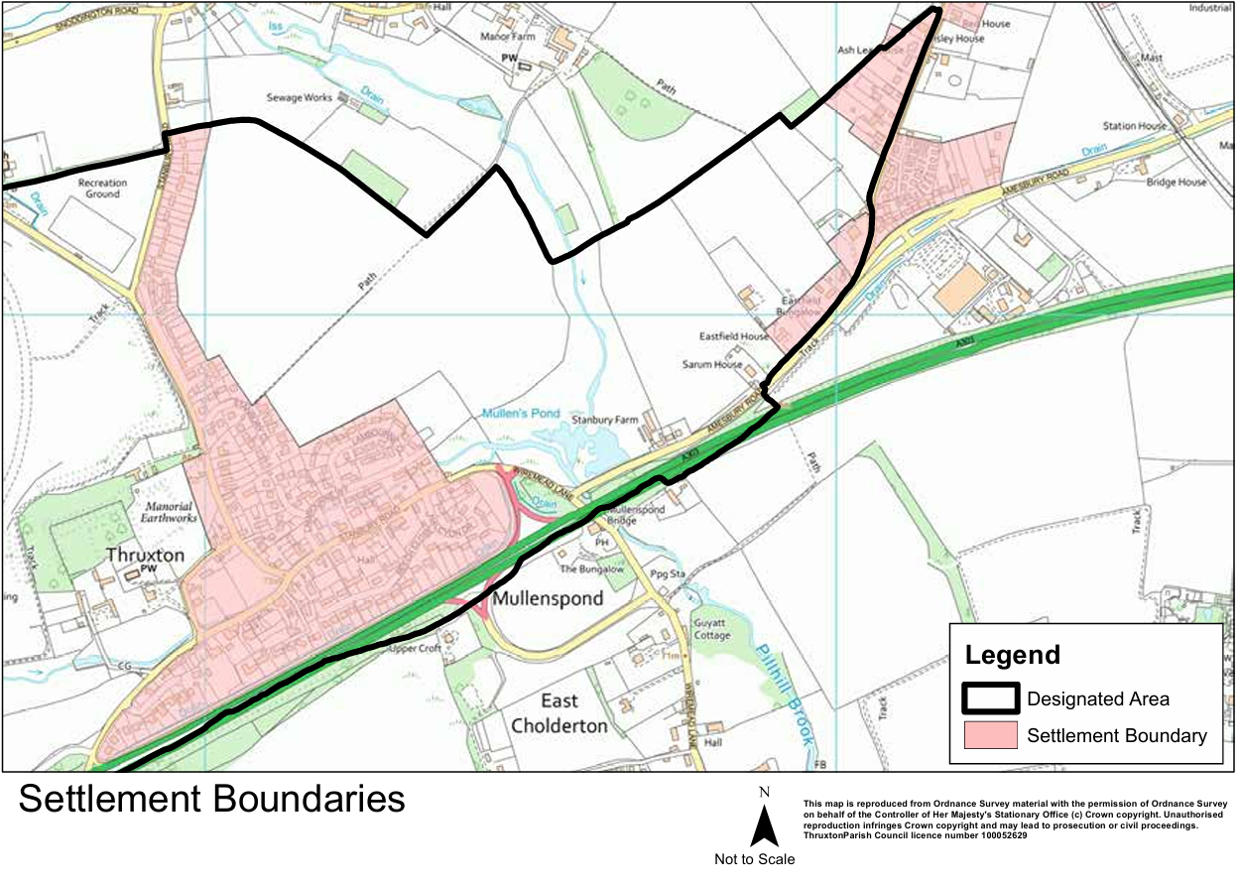

By brownfield, we mean land which has been previously developed with some form of permanent structure.
By greenfield, we mean land which has never been developed in that way (e.g. farmland).

Q 22. Do you think any new housing is needed within the Parish?
 1 Yes
 2 No

Q 23. Thinking about Thruxton Parish generally, what types of housing do you think are most needed?
Please score all below from 1 to 5, with one being lowest needed and 5 being of highest need.

a. 1-2 bed houses 1 2 3 4 5
b. 2-3 bed houses 1 2 3 4 5
c. 3-4 bed houses 1 2 3 4 5
d. 5+ bed houses 1 2 3 4 5
e. Bungalows 1 2 3 4 5
f. Flat/apartment 1 2 3 4 5

Q 24. Should those properties be? Answer all that you feel are applicable.
a. Eco-friendly - (Eco-friendly homes are low-maintenance and have a minimal impact on the environment. They are built with several sustainable factors in mind to reduce carbon footprint) Yes / No
b. Affordable/Low-cost housing (relative to local incomes) to rent Yes / No
c. Self-build Yes / No
d. Affordable Shared ownership Yes / No
e. Retirement housing Yes / No
f. Social housing Yes / No
g. Warden-assisted retirement housing Yes / No
h. On ‘village typical’ sized plots Yes / No
i. Other (please specify) _______________________________________________________
Do you have any other comments you would like to make? ________________________________________________________________________________
________________________________________________________________________________
Q 25. In the past 15 years, about 5 houses have been built or granted planning permission in Thruxton Parish. How many houses do you think could be sustainably built in Thruxton Parish in the next 15 years (2024 -2039)? (Please tick one of the following options).

a. More than 300 □
b. Up to 300 □
c. Up to 200 □
d. Up to 100 □
e. Up to 50 □
f. Up to 25 □
g. Up to 10 □
h. None □

Q 26. What size of housing developments do you think would be most appropriate to meeting the need for housing in Thruxton Parish? (Please tick all that apply.)
a. Large developments (more than 25 houses) □
b. Medium developments (10 to 25 houses) □
c. Smaller development (fewer than 10 houses) □
d. Individual homes □
e. Other (please specify) ___________________________________________________ □
Q 27. Do you think any development should?:
a. Happen in one go □
b. Be spread over the next 15 years □
Q 28. Sites for Building. The Parish Council can, but does not have to, identify possible sites for development in the Neighbourhood Development Plan. Do you have any comments on where development could be sited within the Parish?
________________________________________________________________________________
________________________________________________________________________________

SECTION 4: Keeping you informed.

We want to keep you informed about the results of this survey. So that we can do this as effectively as possible, please tick any of the following that would apply to you:-
a. I read the Thruxton Times □
b. I look at the village website (www.thruxtonvillage.com) (Please circle) □ Regularly Occasionally Never
c. I look at the Thruxton Village Facebook Pages □
d. I would come to look at an exhibition/hear a short talk in the Hall □
e. I don’t want to know further about the Thruxton Housing Needs Survey □

SECTION 5: Any other comments

Please provide any additional comments, ideas, or observations you have. ________________________________________________________________________________
________________________________________________________________________________
________________________________________________________________________________
________________________________________________________________________________

SECTION 6: Required information
ABOUT YOU
Please provide us with the following information about you. This will help us to understand the pattern of responses. Your data will be used for the purposes of the survey only and will not be shared with anyone outside of the Parish Council and will be kept confidential. Your response will not be identifiable in any future document or presentation.
Postcode: __________________________________
House Number/Name (only if multiple returns being sent in): ________________________
Age:

under 18
18-24
25-34
35-44
45-54
55-64
65-74
75-84
Over 85

Do you identify as:
Male
Female
Other
How would you describe your ethnic origin?
Asian or Asian British
Black or Black British
Mixed
White
Other ethnic group

SECTION 7: How and when to return this survey
Please return this survey to:
- The Post Box on the Village Hall railings by 23 June 2024 or
- Await collection from your door step on 22/23 June 2024

SECTION 8: Thank you for completing the survey.
This survey will play a very important part in enabling the Parish Council to represent your views when influencing the development of our Parish in the future. Thank you for completing it.

SPEED CONTROLS IN THRUXTON VILLAGE
In addition to gathering your thoughts and opinions on Housing, we also want to ask two questions about speed controls through the village. Unfortunately, we have been unable to persuade Hampshire Highways to change the speed limit along Thruxton Down Road but they are willing to consider introducing a 20mph speed limit through the village if it can be shown that residents support this change.
Q1. Speed Limit: Would you be in favour of reducing the speed limit from 30mph to 20 mph through the village – i.e. on Village Street, Stanbury Road and all side roads that are covered by the current 30mph speed limit?
YES □
NO □
Q2. Speed Controls: Would you be in favour of asking Hampshire Highways to install any of the following speed management measures at the entrances to the village – i.e. on Village Street by the allotments, on Village Street near Lovell Close and on Stanbury Road near the bus stop?
Please put ‘X’ on all that you think should or could be used.
Speed bumps / sleeping policemen □
Islands to narrow the road □
Chicane □
Single lane with priority for traffic in one direction □
More speed warning signs □

Thank you!

